**Draft - TFM: Cluster analysis approach to the relation between the neighborhoods in Madrid and their gentrification**

***Author: Jorge Pascual Segovia***

***Supervisor: Gonzalo Génova***

Madrid, 2023.

# 1. Theoretical framework: The phenomenon of gentrification.

The Right to the city is defined by Henri Lefebvre (1967) as the right of the citizens to **build, create and decide** on their city. This is **not recognized as a human right**, but the concept is strictly linked with the idea of **democracy and social equality**: every citizen should have the same right to create, build and decide on their city. **Gentrification is a problem** as it stands for **class privileges** and causes a difference between classes about **who can decide** where to **live**, when to **stay** and who can take **benefit** for living in an area with a profitable potential; but, overall, the right to decide the direction of the evolution of the city.

Gentrification is the **historical social transformation of the city centers** that started in certain cities in Great Britain and USA in the **last third of the 20th Century**, for example Manhattan. The **emerging middle classes** with highly valued **professional** **skills, linked to the global economy**, known as the ‘gentry’ in Great Britain, gave the name to this process in neighborhoods in the **city centers that they started demanding.** Even though these neighborhoods had usually been **traditional working class areas**; the **city was institutionally changed** to make it **easier for the gentry to live in these areas**, almost forcing people living in those neighborhoods to **disperse** and spread through the city, away from their home. Nowadays, this **process has been extended in the Western world** as this social class was emerging, affecting those cities that respond to the characteristics of a **‘global city’** strongly involved in the global economy network (Sorando & Ardura, 2018) (Sequera, 2014) (Walliser & Sorando, 2019).

There are many examples of this phenomenon, back in the late 20th Century, but also recently in **Spain**, where it’s supposing an **actual problem nowadays, caused by touristification, real estate pressure and speculation**.El Raval (Barcelona), Malasaña (Madrid) and Lavapiés (Madrid) are common examples of gentrified neighborhoods in Spain. According to Sorando & Ardura (2016), **gentrification has an identifiable process** they describe as the *creative destruction of the city*:

1. First, there has to be a **working class city center area** of interest inside a globalized city which can be **economically exploited** by **companies** and demanded by this new kind of **middle class**.
2. Then, the **public government** also has to have a plan to **renew a concrete area** as it can **provide benefits** and **attract** companies with a **high amount of capital**. In the case of el Raval, the old “Barrio Chino”, even a company funded by the government in a half, while the other half was holded by companies as BBVA or Telefónica, is the responsible of administering and coordinating the renewal plans of the most humble neighborhoods in Barcelona. This company is called Foment de Ciudad, SA[1]
3. Stigmatization of neighborhoods and the deterioration of their lifestyles can occur through various means, such as increased police presence and the amplification of incidents occurring within the area. Additionally, limiting investments in neighborhood issues can contribute to its decline over time. The presence of poverty, precarity, and an increased police presence further reinforce the perception of a neighborhood as "dangerous" or "problematic," thus legitimizing interventions and fostering apathy among its inhabitants.
4. Once public authorities have gained credibility and the ability to intervene in these neighborhoods, the actions taken lead to the displacement of residents. This displacement can occur through various means, such as pressuring inhabitants to leave, negotiating with companies on unfavorable terms for the sale of their houses, and ultimately resorting to expropriation of properties at prices that may not adequately reflect their true value.
5. Finally, the estates are **liberalized** and sold at market price, with **promising investments** to renew the neighborhood, attracting the capital from big companies.
6. **The consequences of gentrification are the dispersion of poverty, segregation and the occupation of inhabitants by a privileged class.**

# 2. Research Summary.

This thesis aims to gather information on various variables related to gentrification and utilize the data to conduct a cluster analysis that enables the grouping of different neighborhoods based on their association with gentrification. The primary objective is to identify areas that are more susceptible to the occurrence of gentrification and define the relationship between neighborhoods and the gentrification process in Madrid.

Objectives:

* To compile relevant data on variables linked to gentrification, including but not limited to demographic characteristics, socioeconomic indicators, housing prices, and urban development.
* To perform a cluster analysis on the collected data in order to identify distinct patterns and group neighborhoods based on their level of association with gentrification.
* To determine the areas most susceptible to gentrification in Madrid by identifying clusters characterized by indicators commonly associated with the process.
* To establish a clear relationship between neighborhoods and the occurrence of gentrification, providing insights into the spatial distribution and dynamics of this phenomenon in Madrid.

Hypotheses:

* Neighborhoods with lower education levels, higher unemployment rates and a higher Population Aging index will exhibit a higher likelihood of experiencing gentrification.
* Neighborhoods in close proximity to city centers, transportation hubs, and areas with high cultural amenities, and thus experiencing a significant tourist influx, are likely to exhibit a stronger association with gentrification.
* Areas with significant urban redevelopment projects and rising property prices will be more prone to gentrification.

The findings of this thesis will contribute to the existing literature on gentrification by providing a comprehensive analysis of the factors and neighborhood characteristics associated with this urban process. By identifying areas at higher risk of gentrification, this research will support policymakers, urban planners, and stakeholders in implementing targeted interventions and strategies to mitigate the negative consequences and promote inclusive development in Madrid. These contributions could have a profound and positive impact on addressing and mitigating the growing inequalities among citizens. Furthermore, it can help reduce the dispersion of poverty and provide better opportunities for underprivileged classes and marginalized groups who are at risk of social exclusion.

This unsupervised model is expected to be useful for identifying and preventing this process to occur in an area, protecting the inhabitants’s interests and right to the city, as they are the essence and the main components of the neighborhoods. Also, this thesis will provide important information about the different neighborhoods to decide on which of them are more appropriate for treatment experiments or testing urban policies.

# 3. Methodology

The methodology of this thesis is to **develop a cluster analysis for neighborhoods in Madrid that detects the vulnerability of working class neighborhoods in each of the clusters, by grouping neighborhoods by similarity according to variables that are strongly related to gentrification, i.e. their vulnerability or risk for being gentrified**, **selected after an exhaustive revision of the literature**. Based on the revision done on the sources mentioned below, I decided to select the following list of variables, for the moment, as they respond to a causal explanation of the gentrification phenomenon, according to the bibliography:

* + **Education level**. For getting insights about the social class structure in the different neighborhoods and clusters.
  + **Immigration** proportion and growth of immigration from the previous 4 years.
  + **Real estate prices** and its increment since the previous 4 years.
  + **Airbnb prices, presence and their increment** during the previous 4 years. It will give valuable information about the touristic attractiveness of the areas.
  + **Unemployment** and its growth the past 4 years. For getting insights about the social class structure in the different neighborhoods and clusters.
  + **Loss of population** (Walliser & Sorando, 2019).
  + **Population aging** (Sequera, 2014).
  + **Stigmatization** of the different neighborhoods in twitter by sentiment analysis.

The causality established by theoretical perspectives of the revised literature will be **tested statistically to consolidate or discuss the assumed causality depending on the patterns found**. With that being said, the present thesis does not engage in an examination of the veracity or existence of gentrification as a prevalent issue, as this topic has undergone extensive scrutiny and comprehensive examination, thus affirming the existence of such a phenomenon within the Spanish context, even though there are political and economical interests behind this matter that triggers popular but not scientific controversy (Rubiales, 2014).

### Clustering methodology

For the clustering analysis, I chose to use the **k-means** method, as it fits properly with numerical data, a wide number of variables and fixed clusters, which is adequate for my objective. Hierarchical clustering will also be tested, as the k-means method is limited to the assumption of equal sized spherical clusters, which is not the case as we will see. Both clustering models will be compared and evaluated to choose the method that better minimizes the error, as well as the differences within clusters, and better differentiate between them.

### Data processing strategy

Using RStudio with R language, I stored the data available of the already mentioned variables, in the **years 2015 and 2019** (in order to compute the **increment of certain variables**) that are involved in the gentrification process of a neighborhood. R allows me to compute new variables or summarize them, as well as merge all of the data together, develop the cluster analysis and visualizations of the results. In the following table, it can be seen the source used in this thesis for each of the variables.

It has to be taken into account that there are severe limitations to obtain updated open information about variables related to gentrification because of an apparent lack of interest of Spanish institutions to gather and properly publish data periodically. For the largest part of information related to social class structure, such as occupational data (Rubiales ,2014).

| VARIABLE | SOURCE |
| --- | --- |
| Education level | *Ayto. de Madrid, Open Data Portal. Information panel per dsitrict and neighborhood*: <https://datos.madrid.es/portal/site/egob/menuitem.c05c1f754a33a9fbe4b2e4b284f1a5a0/?vgnextoid=71359583a773a510VgnVCM2000001f4a900aRCRD&vgnextchannel=374512b9ace9f310VgnVCM100000171f5a0aRCRD&vgnextfmt=default> |
| Immigration | *Ayto. de Madrid, Banco de datos. Population per district, neighborhood and nationality*:  Source (2019): <https://www-s.madrid.es/CSEBD_WBINTER/seleccionSerie.html?numSerie=0307010000012>  Source (2015): <https://www-s.madrid.es/CSEBD_WBINTER/seleccionSerie.html?numSerie=0307010000011> |
| Real Estate prices | *Ayto. de Madrid, Banco de datos. Evolution of Real Estate prices of pre-owned housings*: https://www-s.madrid.es/CSEBD_WBINTER/seleccionSerie.html?numSerie=0504030000200 |
| Airbnb data | *Aggregated by Inside Airbnb, the following webpage, web-scraping public information in airbnb.com*: <http://insideairbnb.com/get-the-data> |
| Unemployment | *Ayto. de Madrid, Banco de datos. Registered unemployment per neighborhood*:  Source (2019): <https://www-s.madrid.es/CSEBD_WBINTER/seleccionSerie.html?numSerie=0904040000013>  Source (2015): <https://www-s.madrid.es/CSEBD_WBINTER/seleccionSerie.html?numSerie=0904040000011> |
| Loss of population | Immigration data also contains the population per neighborhood for each year. |
| Population aging | <https://www-s.madrid.es/CSEBD_WBINTER/seleccionSerie.html?numSerie=0301000000001> |
| Stigmatization | Twitter API |

There were several decisions that had to be taken due to the format of the data available and its characteristics when manipulating and merging the data. The diverse data sources presented a challenge in terms of compatibility, as they varied in file types, structures, and naming conventions. In order to ensure smooth data integration, careful consideration was given to selecting the appropriate data transformation techniques. These decisions were crucial in maintaining data integrity and ultimately providing a solid foundation for further analysis and decision-making.

Some neighborhoods had different denominations in the different datasets, for example Peñagrande (Peña Grande); a name changing throughout the years like Palos de Moguer to Palos de la Frontera and some others were new in 2019, which is the case of Ensanche de Vallecas. To solve the denomination problems, I used the neighborhood code columns to identify the specific denomination of the neighborhoods with this issue and built string manipulation syntaxes that I could use with different datasets. To address the issues related to the new neighborhoods, which lacked data for 2015 and growth variables, a decision was made to exclude them from the analysis. This choice was based on several factors: the new neighborhoods exhibited a distinct socio-demographic structure compared to the rest of the neighborhoods, they were not undergoing gentrification but rather other urbanism processes, and the data available for these neighborhoods was incomplete. Additionally, when subjected to cluster analysis, these neighborhoods formed a separate and exclusive cluster, further justifying their removal from the analysis.

There were several neighborhoods like Atocha that presented missing values in the Real estate prices dataset from Ayto. de Madrid. A missing value proportion of 12.2% in 2015 data, and 9.9% in 2019 data. As it was a fairly important proportion, and the neighborhoods missing didn’t show any pattern, I decided to estimate the missing values using “Mice” by Predictive Mean Matching imputation method with kN-Neighbors algorithm.

The last important limitation I faced when processing the data, was that there were many variables that I wanted to add, like the movements of the population in terms of emigrants and immigrants of each neighborhood, or the police presence. The problem was that the data was only available for districts, which was a big limitation that made me decide not to include these variables nor estimate them. Also, the income information was available in a map format, but the data wasn’t available in “csv.” or other formats that could be treated with R.

# 3. Results

As Hierarchical and K-means methods require a predefined number of clusters, I decided to estimate it with Gap Statistics, a Machine Learning method that consists of quantifying the clustering quality based on the gap between the observed within-cluster dispersion and its expected value under null reference distributions. This approach takes into account both the compactness of the clusters and the separation between them. Gap Statistics offers a data-driven approach to cluster analysis, providing valuable insights into the underlying structure of the data and aiding in informed decision-making for clustering tasks. In this case, the optimal number of clusters computed is 3, which is a low number of clusters for describing the differences between neighborhoods properly. The next optimal value was selected, designing a cluster analysis for **6** groups.

To determine whether to use hierarchical clustering or k-means clustering, the within-cluster similarity was computed for both models. The following results indicate that the clusters generated by the hierarchical method exhibit more optimal values and demonstrate greater homogeneity, as we can see in the following table of my own elaboration. Therefore, the results from the hierarchical clustering will be used for the analysis.

*K-means method*

* Cluster 1 homogeneity: 0.4259097
* Cluster 2 homogeneity: 0.7700548
* Cluster 3 homogeneity: 0.3917723
* Cluster 4 homogeneity: 0
* Cluster 5 homogeneity: 0.7222127
* Cluster 6 homogeneity: 0.1633048

*Hierarchical method*

* Cluster 1 homogeneity: 0.3153837
* Cluster 2 homogeneity: 0.4401724
* Cluster 3 homogeneity: 0.3808216
* Cluster 4 homogeneity: 0.4505045
* Cluster 5 homogeneity: 0.2591299
* Cluster 6 homogeneity: 0.265247

The results of the Hierarchical clustering of the different neighborhoods show apparent gentrification patterns in some of the areas, but don’t define strictly the areas that are or are not being gentrified, although it provides valuable insights about the relationship between each group of neighborhoods and the gentrification process or interest.

|  | **C1** | **C2** | **C3** | **C4** | **C5** |
| --- | --- | --- | --- | --- | --- |
| **prop_foreign** | 0.2296 | 0.1492 | 0.1213 | 0.1393 | 0.1284 |
| **foreign_incr_last_4_years** | 0.0242 | 0.0249 | 0.0249 | 0.0343 | 0.0310 |
| **house_price_2019** | 51.480.000 | 37.609.907 | 32.096.524 | 32.265.714 | 25.941.667 |
| **house_price_incr_last_4_years** | 0.4145 | 0.4058 | 0.3206 | 0.3424 | 0.2774 |
| **n_airbnbs** | 6.591.667 | 518.704 | 156.286 | 0.0000 | 45.556 |
| **mean_airbnb_price** | 1.164.903 | 848.615 | 708.708 | 0.0000 | 693.557 |
| **n_airbnb_incr_last_4_years** | 5.316.667 | 460.000 | 132.000 | 0.0000 | 45.556 |
| **airbnb_price_incr_last_4_years** | 106.286 | 296.938 | -102.087 | 0.0000 | 693.557 |
| **unem_prop_2019** | 0.0484 | 0.0378 | 0.0435 | 0.0440 | 0.0508 |
| **population_incr_last_4_years** | 10.781.667 | 11.757.222 | -3.474.000 | 37.285.000 | 6.015.000 |
| **unem_incr_last_4_years** | -0.0189 | -0.0214 | -0.0158 | -0.0150 | -0.0172 |
| **Unknown_studies** | 0.0007 | 0.0016 | 0.0012 | 0.0015 | 0.0008 |
| **Non_literate** | 0.0257 | 0.0380 | 0.0461 | 0.0507 | 0.0695 |
| **Incomplete_elementary** | 0.0713 | 0.1026 | 0.1041 | 0.1128 | 0.1349 |
| **Compulsory_educ** | 0.1797 | 0.2421 | 0.2461 | 0.2592 | 0.2893 |
| **FP_or_pre_college** | 0.1868 | 0.1891 | 0.1951 | 0.1925 | 0.1800 |
| **College_graduate** | 0.0984 | 0.0981 | 0.1028 | 0.0908 | 0.0863 |
| **Post_graduate** | 0.4374 | 0.3285 | 0.3047 | 0.2925 | 0.2392 |
| **Aging_index_2019** | 0.1642 | 0.2175 | 0.1955 | 0.2084 | 0.1839 |
| **aging_index_incr** | -0.0054 | -0.0033 | 0.0093 | -0.0024 | -0.0044 |

For instance, we can find clusters defined by a working social class with relevant indicators of gentrification, and others that are not being affected because of a lack of interest in those areas due to the social class structure, the lack of amenities in the area or the distance from the city center. We can observe as well some clusters characterized by a privileged social class structure which shows signs either of previous gentrification or that are traditionally privileged class neighborhoods. In the following dendrogram, you can find the cluster to which each neighborhood belongs. Also, we can visualize the neighborhood in the following map, created with the leaflet package in R:

## 

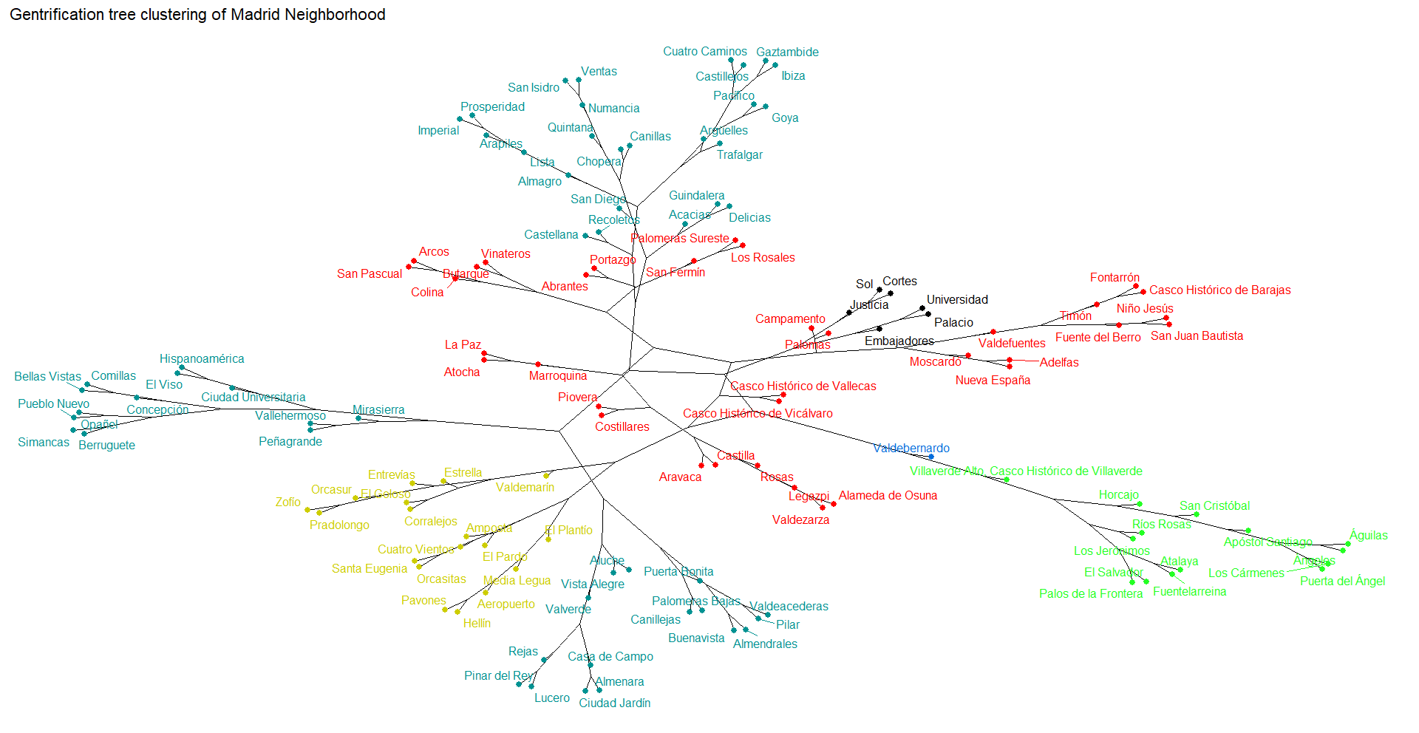

## **Cluster 1: The city center**

These neighborhoods in the center are characterized by an estimated high social class, as it shows a relatively low unemployment rate(4.84%), which has decreased 1.89% during the last 4 years. In education terms, it shows the biggest proportion of post-graduated people (43.74%) and high real estate prices (€5.15 M), while maintaining the lowests proportions of people with studies below Spanish FP or precollege.It is the most affected cluster by airbnb number of housings (659, increasing by a mean of 531 per neighborhood) and it has the highest mean price of $116.49, which has slightly increased by $10.63 during the last 4 years, if we compare it with the next clusters. This would represent already gentrified neighborhoods in the center, or neighborhoods that traditionally had these characteristics. In this cluster we find Malasaña, which is one of the canonical examples of gentrified neighborhoods in Madrid (CITAR).

In the first cluster, the neighborhood of *Embajadores* stands out as the most prominent. It can be inferred that the residents in this neighborhood belong to a less privileged social class compared to the other neighborhoods in the cluster. Embajadores exhibits several distinct characteristics: a notably higher unemployment rate of 5.65%, the lowest real estate prices within the cluster at €4.48 M, and a higher proportion of residents who have completed their education before compulsory education and elementary levels. Conversely, Embajadores has the lowest proportion of post-graduates and college graduates in the cluster.

Furthermore, it is worth noting that Embajadores has experienced a significant increase in the number of Airbnb amenities, with 860 listings compared to the cluster average of 531.67. Based on this information, it can be concluded that the gentrification process in Embajadores is less consolidated compared to other neighborhoods in the city center. Additionally, Embajadores appears to be the most vulnerable neighborhood within the cluster, indicating a higher likelihood of experiencing the gentrification process.

## **Cluster 2: High relationship with gentrification area**

The second cluster comprises a diverse range of neighborhoods, spanning from the periphery of the city such as Fuencarral, Mirasierra, Buenavista, and Rejas, to the surrounding areas of the city center including Argüelles, Gaztambide, Acacias, and Recoletos. As a result, there is a wide variation in the level of gentrification influence within this cluster. The defining characteristics of the second cluster include a higher proportion of high social class residents and a significant presence of middle-class individuals, as evidenced by the data. It is noteworthy that this cluster exhibits the second-highest house prices among the different clusters (€3.76 M), the second-highest proportion of post-graduates (32.85%), and the lowest unemployment rate (3.78%).

However, it is important to highlight that this cluster also displays patterns that do not exhibit a consolidated presence of high social class inhabitants, unlike the first cluster. The values in this cluster are closer to those observed in the rest of the clusters, particularly in terms of the proportion of individuals who have completed compulsory education or have not completed elementary education. This observation, considering the hierarchical clustering method employed, suggests that there is a greater diversity among neighborhoods in this cluster. While this cluster can be defined as privileged in terms of social class, its proximity to other clusters and the variation within the neighborhoods indicate that there is considerable diversity within the group.

Within this cluster, the influence of Airbnb is the second highest, characterized by 52 listings and an average price of $84.86, which has witnessed an increase of $29 over the past four years. The real estate prices in this cluster have risen by 40.58%, placing them closer to the neighborhoods in the city center cluster (41.45%) rather than the other clusters, where the price growth is less than 35%.

In conclusion, neighborhoods within this cluster that have lower education levels, lower real estate prices, higher unemployment rates, and a stronger presence of Airbnb listings are more susceptible to experiencing the effects of gentrification. It is also important to note that this cluster has the highest average Population Aging Index, further increasing its vulnerability to the impacts of gentrification.

Among the neighborhoods in this cluster, San Diego, Almendrales, Numancia, San Isidro, Vista Alegre, Aluche, and Opañel are particularly vulnerable. These neighborhoods exhibit a high concentration of Airbnb listings and indicators that suggest a predominance of working-class citizens. Despite this, the real estate prices in these neighborhoods are clearly increasing, as we can see in the following table. It’s important to notice that these neighborhoods show significant statistical similarities with wealthier neighborhoods like Castellana and Recoletos. For instance, Castellana has an average house price of €7.12 million, Recoletos has an average price of €8.44 million, while the cluster's overall average is €3.76 million. Additionally, Castellana and Recoletos have a high proportion of post-graduates (58.67% and 55.94%, respectively), compared to the cluster average of 32.85%.

|  | **h**  **o**  **u**  **s**  **e**  **p**  **r**  **i**  **c**  **e** | **nº**  **a**  **i**  **r**  **b**  **n**  **b**  **s** | **nº**  **a**  **i**  **r**  **b**  **n**  **b**  **s**  **i**  **n**  **c**  **r** | **a**  **i**  **r**  **b**  **n**  **b**  **p**  **r**  **i**  **c**  **e** | **u**  **n**  **e**  **m**  **p**  **l**  **o**  **y**  **m**  **e**  **n**  **t** | **p**  **o**  **s**  **t**  **g**  **r**  **a**  **d**  **u**  **a**  **t**  **e** | **c**  **o**  **m**  **p**  **u**  **l**  **s**  **o**  **r**  **y**  **e**  **d**  **u**  **c** | **n**  **o**  **e**  **l**  **e**  **m**  **e**  **n**  **t**  **a**  **r**  **y** | **a**  **g**  **i**  **n**  **g**  **i**  **n**  **d.**  **i**  **n**  **c**  **r** | **h**  **o**  **u**  **s**  **e**  **p**  **r**  **i**  **c**  **e**  **i**  **n**  **c**  **r** |
| --- | --- | --- | --- | --- | --- | --- | --- | --- | --- | --- |
| **San Diego** | 1.92 | 82 | 71 | 703.780 | 0.0729 | 0.1021 | 0.4089 | 0.1769 | -0.0231 | 0.4399 |
| **Puerta Bonita** | 1.94 | 22 | 20 | 607.727 | 0.0658 | 0.1121 | 0.3841 | 0.1761 | -0.0205 | 0.4103 |
| **Almendrales** | 2.18 | 25 | 25 | 436.400 | 0.0616 | 0.1149 | 0.3963 | 0.1880 | -0.0203 | 0.4418 |
| **Numancia** | 2.08 | 59 | 53 | 528.305 | 0.0712 | 0.1156 | 0.3709 | 0.1843 | -0.0076 | 0.4260 |
| **Vista Alegre** | 2.04 | 40 | 34 | 452.250 | 0.0055 | 0.1230 | 0.3748 | 0.1717 | -0.0139 | 0.3801 |
| **Palomeras Bajas** | 2.10 | 23 | 22 | 894.348 | 0.0639 | 0.1260 | 0.3640 | 0.1599 | 0.0018 | 0.5036 |
| **San Isidro** | 2.30 | 53 | 49 | 599.811 | 0.0072 | 0.1428 | 0.3539 | 0.1727 | -0.0112 | 0.4295 |
| **Canillejas** | 2.36 | 20 | 19 | 643.500 | 0.0052 | 0.1490 | 0.3479 | 0.1686 | 0.0047 | 0.4595 |
| **Aluche** | 2.21 | 29 | 27 | 381.724 | 0.0446 | 0.1494 | 0.3256 | 0.1730 | -0.0053 | 0.3991 |
| **Opañel** | 2.33 | 40 | 36 | 821.500 | 0.0540 | 0.1591 | 0.3553 | 0.1533 | -0.0110 | 0.4099 |
| **Buenavista** | 2.50 | 25 | 25 | 487.200 | 0.0507 | 0.1629 | 0.3364 | 0.1241 | -0.0052 | 0.2727 |
| **Pueblo Nuevo** | 2.49 | 46 | 41 | 685.435 | 0.0475 | 0.1640 | 0.3372 | 0.1502 | -0.0076 | 0.4403 |
| **Lucero** | 2.38 | 31 | 26 | 544.194 | 0.0529 | 0.1697 | 0.3191 | 0.1571 | -0.0147 | 0.4294 |
| **Ventas** | 2.66 | 54 | 49 | 650.185 | 0.0499 | 0.1755 | 0.3279 | 0.1503 | -0.0167 | 0.4595 |
| **Comillas** | 2.70 | 46 | 44 | 896.739 | 0.0575 | 0.1805 | 0.3242 | 0.1485 | -0.0076 | 0.5538 |

## **Cluster 3: Polarized area**

Observing the location of the neighborhoods in this cluster we find that they are located mostly in the periphery of the city and are surrounded mainly by neighborhoods belonging to the second cluster. The neighborhoods of Retiro and Atocha are the nearest to the city center.

If we take a glance at the centers of the cluster, we find that there is a lower gap between people who finished post-graduate studies (30.47%) and those with lower education level (10% of people with uncompleted elementary studies). In fact, there are more people who just finished compulsory education, 24.61% or pre-college studies, 19.51%, than college graduates, which represents a mean of 10.28% of the neighborhood’s population. On the other hand, the unemployment rate (4.35%) is similar to the unemployment mean between clusters, 4.49%.

From this information, we can confirm that the social structure of these neighborhoods are mainly based on middle classes, but also by a diversity of working class and privileged class patterns. Therefore, the question here is which is the relationship that these socially diverse neighborhoods keep with gentrification? If we observe the airbnb influence, it’s significantly lower than the first two clusters, but the evolution of the Airbnb influence is not clear as, for example, the prices are decreasing while the supply is increasing, suggesting that this issue is also polarized between different neighborhoods. This can mean that the gentrification process is less consolidated than in the first clusters, but it’s also present in some areas as we can observe that in this clusters there are working class neighborhoods with significant statistical similarities to middle classes and privileged classes, according to the considered variables.

|  | **C1** | **C2** | **C3** | **C4** | **C5** |
| --- | --- | --- | --- | --- | --- |
| **house_price_2019** | 51.480.000 | 37.609.907 | 32.096.524 | 32.265.714 | 25.941.667 |
| **house_price_incr_last_4_years** | 0.4145 | 0.4058 | 0.3206 | 0.3424 | 0.2774 |
| **n_airbnbs** | 6.591.667 | 518.704 | 156.286 | 0.0000 | 45.556 |
| **mean_airbnb_price** | 1.164.903 | 848.615 | 708.708 | 0.0000 | 693.557 |
| **n_airbnb_incr_last_4_years** | 5.316.667 | 460.000 | 132.000 | 0.0000 | 45.556 |
| **airbnb_price_incr_last_4_years** | 106.286 | 296.938 | -102.087 | 0.0000 | 693.557 |

## In the following table, you can find the various neighborhoods that exhibit indications of being linked to the gentrification process in this cluster for different reasons. These neighborhoods display notable characteristics, such as escalating property prices, number of Airbnb listings and characteristics indicating a middle or working class social structure in the neighborhood, such as higher unemployment rates. These factors collectively contribute to the transformation of these areas, attracting investment and potentially resulting in harmful consequences for the most modest neighbors.

|  | **Real estate price** | **Real estate prices increase** | **Nº of airbnbs listings** | **Post graduate proportion** | **Unemployment rate** |
| --- | --- | --- | --- | --- | --- |
| Casco Histórico de Vallecas | 2356.5 | 0.6422 | 29 | 0.0768 | 0.0782 |
| Arcos | 2130.0 | 0.5720 | 16 | 0.1266 | 0.0622 |
| Portazgo | 1826.0 | 0.4738 | 10 | 0.0784 | 0.0750 |
| Los Rosales | 1869.0 | 0.4355 | 13 | 0.1041 | 0.0601 |
| Moscardó | 2209.0 | 0.4353 | 29 | 0.1268 | 0.0534 |
| Palomeras Sureste | 2012.0 | 0.2718 | 18 | 0.0995 | 0.0659 |
| San Fermín | 2041.0 | 0.2325 | 16 | 0.1078 | 0.0691 |
| Casco Histórico de Barajas | 3104.0 | 0.2327 | 16 | 0.1408 | 0.0494 |
| Fontarrón | 2207.0 | 0.3449 | 14 | 0.1424 | 0.0554 |

When taking into account the data from the different neighborhoods in this cluster, we find interesting patterns that clearly indicate a considerable risk of gentrification for specific neighborhoods in this cluster. A very interesting pattern is that there are some neighborhoods in which the proportion of post-graduated inhabitants is very low and the house price is increasing more than the neighborhoods with the higher post-graduates proportion, as we can observe in the following graph.

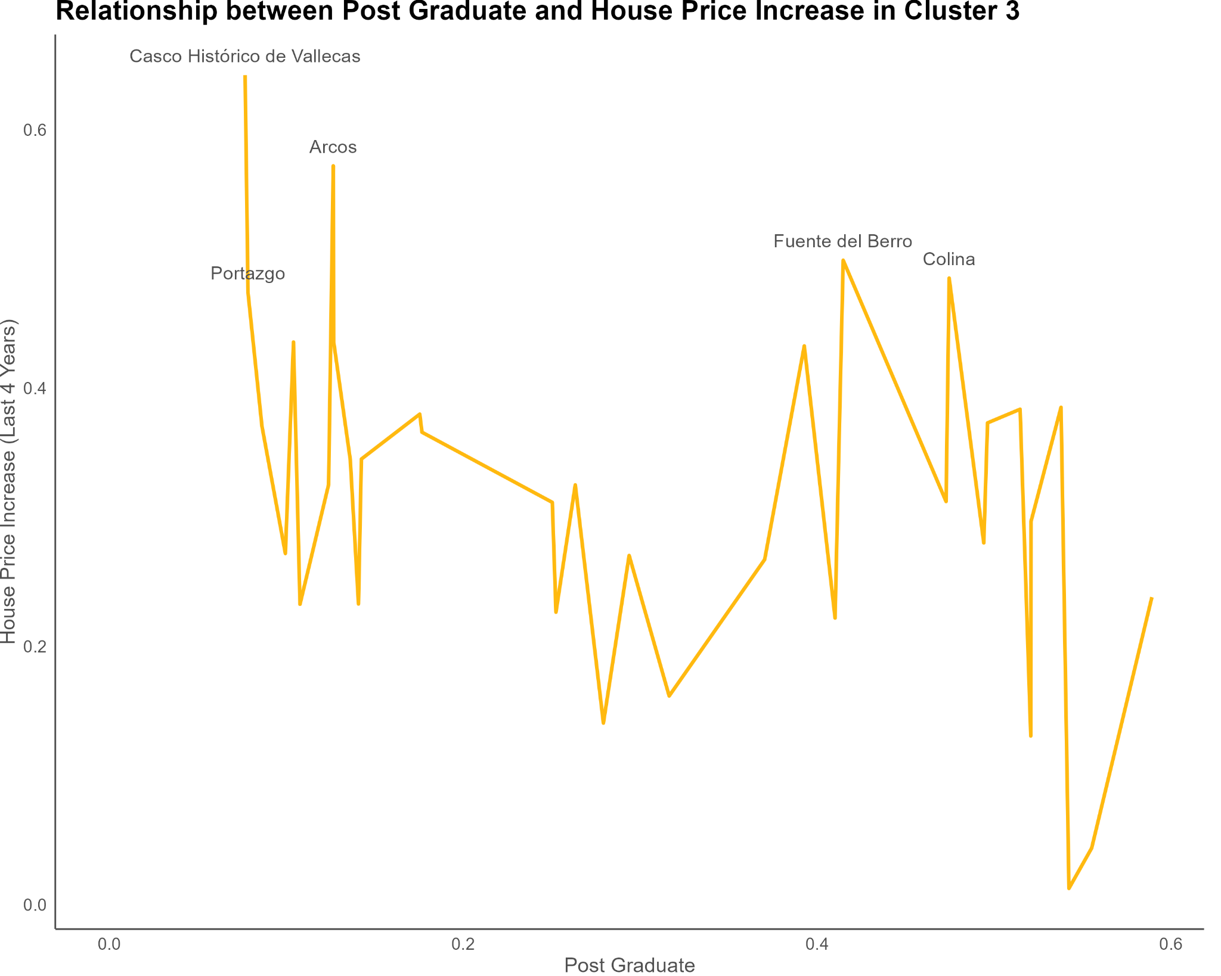

The neighborhoods exhibiting more severe signs of gentrification within this cluster include Casco Histórico de Vallecas, Portazgo, Arcos, Los Rosales, and Moscardó. In particular, Casco Histórico de Vallecas and Portazgo have the lowest proportions of individuals with post-graduate education (7.68% and 7.84%, respectively) and a significant proportion of residents who have only completed compulsory education (40.04% and 37.85%, respectively) or have not finished elementary school (18.59% and 21.6%, respectively). Additionally, these neighborhoods exhibit elevated unemployment rates (7.82% and 7.5%, respectively), further indicating a predominantly working-class population.

Furthermore, Casco Histórico de Vallecas and Moscardó stand out due to their higher presence of Airbnb listings, with 29 listings compared to the cluster's average of 15.63. This suggests an increased influence of short-term rentals and potentially higher demand from tourists or visitors in these neighborhoods. The remaining neighborhoods in the past table exhibit similar patterns associated with gentrification, although slightly less pronounced.

The combination of these factors points to a more advanced stage of gentrification in Casco Histórico de Vallecas, Portazgo, Arcos, Los Rosales, and Moscardó. These findings highlight the socio-economic shifts occurring in these areas and the potential challenges faced by the local communities in the face of gentrification.

## 

## **Cluster 4:**

1. The social class of these neighborhoods can be estimated from several patterns that show working class characteristics: low education level, low real estate and airbnb prices, high unemployment rate and low unemployment decrease.
2. It’s a cluster clearly affected by airbnb and whose prices are growing, as well as for the real estate market. The number of Airbnb housings is increasing as has a relatively high number of them.

## **Cluster 5:**

1. In this neighborhood we can estimate that the social class is less privileged as it’s the cluster with lower education level and the highest unemployment rates. We can also tell that it is a cluster with neighborhoods inhabited by a large proportion of immigrants which is also increasing, even though the population of the neighborhood is decreasing.
2. Airbnb is slightly affecting these neighborhoods, as price is increasing and the cluster is characterized by a fairly high amount of airbnb housings. On the other hand, the number of airbnbs is quite low and the number of airbnbs is slightly decreasing.
3. This cluster represents working class neighborhoods in which the variables involved in gentrification are not sufficiently explanatory of the phenomenon, probably because the interest in these areas is not as high, or they are not considered as valuable as other neighborhoods.

# Bibliography:

* De la Calle Vaquero, M. (2019). Turistificación de centros urbanos: clarificando el debate. *Boletín de la Asociación de Geógrafos Españoles*, vol. 83, nº 2829, pp. 1–40. http://dx.doi.org/10.21138/bage.2829
* Foment de Ciudad, SA, official web page: <https://ajuntament.barcelona.cat/fomentdeciutat/es/quienes-somos>
* Lefebvre, H. (1975). “El derecho a la ciudad”. *Península*, 3ª ed. Barcelona. [1967].
* Rubiales, M. (2014). “¿Medir la gentrificación? Epistemologías, metodologías y herramientas de investigación de carácter cuantitativo y mixto”. *Contested Cities*. Barcelona.
* Sequera, J. (2014) "Gentrificación en el centro histórico de Madrid: el caso de Lavapiés". In: Hidalgo, R. & Janoschka, M. (Eds.) “La ciudad neoliberal. Gentrificación y exclusión en Santiago de Chile, Buenos Aires, Ciudad de México y Madrid". *Serie Geolibros* nº 19, pp. 233-25. Santiago de Chile.

Available at: [https://dialnet.unirioja.es%2Fdescarga%2Farticulo%2F3262724.pdf&usg=AOvVaw3KPE0aLFel21o_p99trC9W](https://www.google.es/url?sa=t&rct=j&q=&esrc=s&source=web&cd=&ved=2ahUKEwjY857D9739AhWKTKQEHbMiDXwQFnoECA8QAQ&url=https%3A%2F%2Fdialnet.unirioja.es%2Fdescarga%2Farticulo%2F3262724.pdf&usg=AOvVaw3KPE0aLFel21o_p99trC9W)

* Sorando, D. & Ardura, A. (2016) “First we take Manhattan”. *Los Libros de la Catarata*, Madrid.

Available at: <https://bibliotecacomplutense.odilotk.es/info/00544427>

* Sorando, D. & Ardura, A. (2018) “Procesos y dinámicas de gentrificación en las ciudades españolas”. *Institut d’Estudis Regionals i Metropolitans de Barcelona (ERMB)*. Barcelona.
* Walliser, A. & Sorando, D. (2019) “Las ciudades en España y el impacto de la globalización sobre los sistemas urbanos”. *Informe España 2019*, Madrid. Available at: <https://blogs.comillas.edu/informeespana/informe-espana-2019/>

1. Foment de Ciudad, SA, official web page: [Foment de Ciudad, SA, es una empresa municipal especializada en la gestión de proyectos integrales, transversales y con implicación ciudadana y territorial que lidera proyectos de ciudad de gran trascendencia | Fomento de Ciudad (barcelona.cat)](https://ajuntament.barcelona.cat/fomentdeciutat/es/quienes-somos)